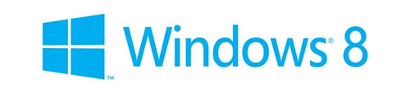

Microsoft has finally released the Windows 8 Consumer Preview. Though still in its beta stage, we can draw a picture of what the final product is going to be. According to Steven Sinofsky, President of Microsoft’s Windows Business division Windows 8 is a “generational change” of the Windows operating system. The last time windows had a generational change was Windows 95. It’s a huge radical rethinking of Windows — and one that’s beautiful, logical and simple.
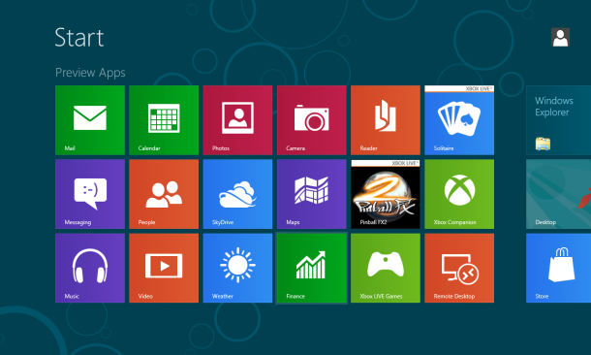

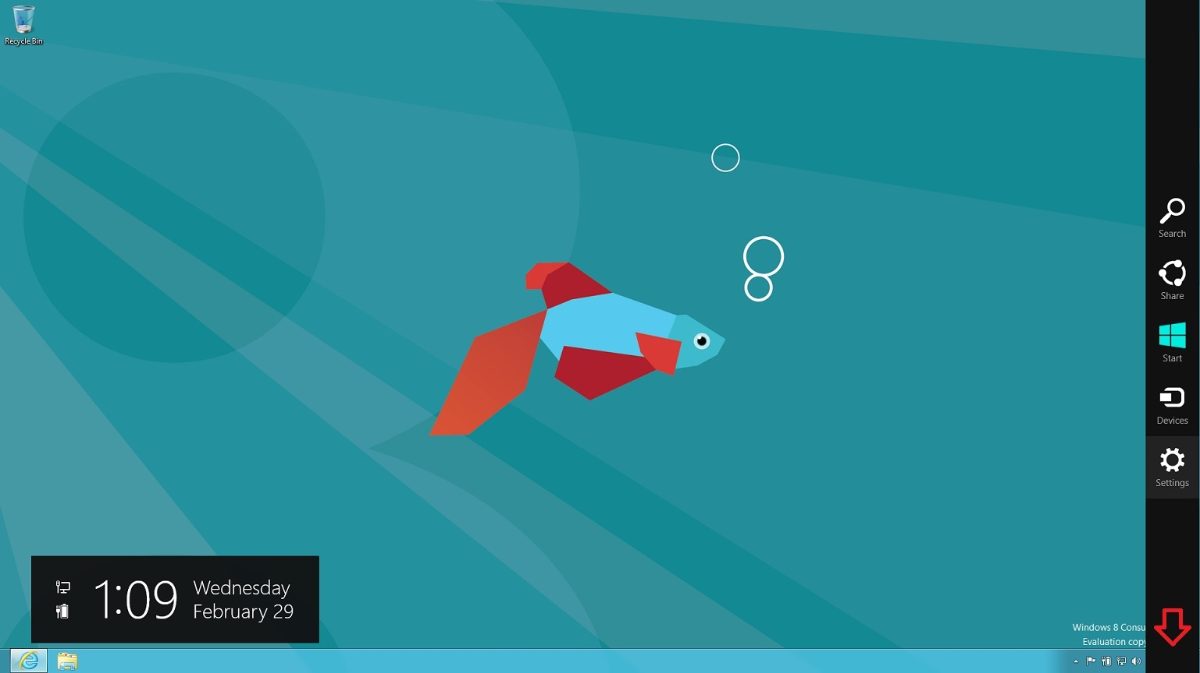
So what’s new in windows 8?Microsoft has incorporated a new Metro-style interface on to the already popular and polished windows 7 interface .The metro interface has been designed mainly for touchscreen input and doesn't look that different from the interface on windows mobile. In essence, it brings the attractive, useful concept of Start-screen tiles, currently available on Windows Phone 7 phones, to laptops, desktop PC’s and tablets. This has been done in order to decrease the gap between the mobile and computer environment. It has your email, photos, appointments and friends pinned to it livens it up considerably - as does the new Metro tile for the desktop. The good old start button has also replaced with the new start screen. Charm bar is also included which shows up when mouse is brought to the right edge of the screen. Search, Share, Start, Devices and Settings shortcuts are shown on the charm bar. Moving the mouse to the left edge reveals the Start, which is highlighted in the accent color of the color theme you choose, swaps between the Start screen and whatever you were doing last. There is an onscreen touch keyboard available which offers four layouts for convenience. Windows also come with an app store pre-loaded making it easier for users to search and download apps and also has the latest version of internet explorer running on it.

Charm Bar
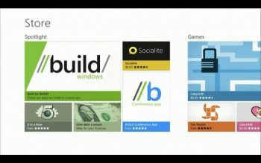
The world has gone app-berserk. Everyone these days is counting on apps for doing their work. So, it was about time Microsoft came out with a proper way of browsing for applications with the release of the Microsoft Store in the Consumer Preview of Windows 8. Just like any other place where applications are offered free or not, the Microsoft Store shares the same basic features with them. You can browse for apps which are sorted by categories for better organization, or just type an app and search for it. The home page of the MS Store acts like a spotlight where you can see the latest and trending applications. The apps downloaded from the store are displayed on the start page.

The start page also consists of preloaded apps like - mail, calendar, contacts, messaging, photos and social networking, plus an app for exploring your files on SkyDrive which are displayed in form of metro tiles. There is even an option to make this tiles live which will make the tiles more interactive.
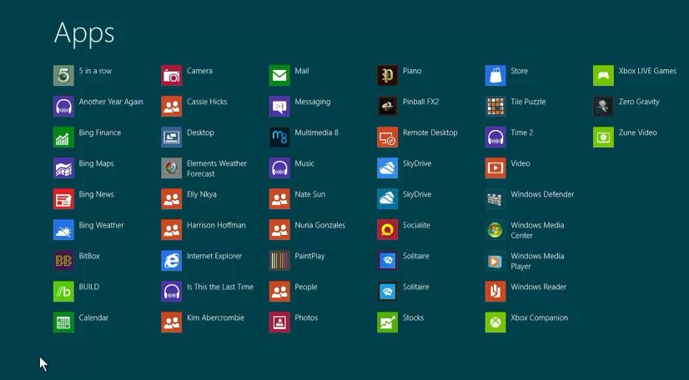

The Mail app is better, although you can only use it with Hotmail, Gmail and Exchange accounts, and while it's easy to jump between accounts and folders, there's no conversation view and you can't flag email or even mark it as spam.
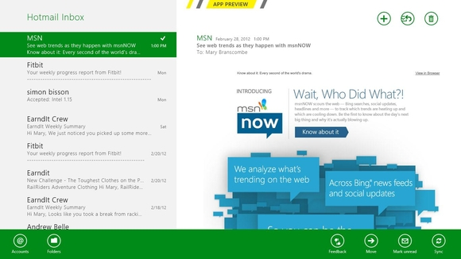
Messaging app makes good use of the size of a PC screen to show you multiple conversations on Facebook and Windows Live, with details about your contacts so you can see what they're talking about on other services. One can also send group messages, but it's just text chat; no voice or video yet.
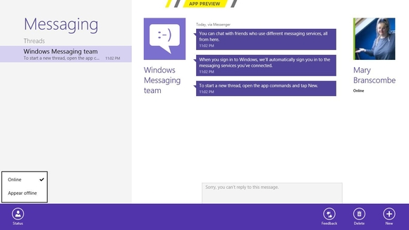

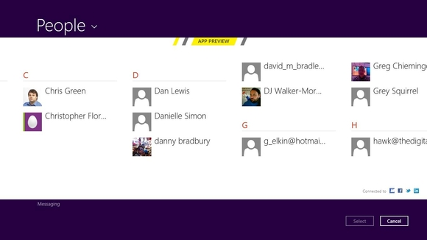
The People app is similar to the Windows Phone tool; in that it combines the address books for all the services you link Windows to, through your live account or by adding specific accounts for email and calendar.
The Photos app enables you to explore your images, whether they're on your PC or online services such as SkyDrive, Facebook and Flickr.it even plays a slideshow in the live tile mode. There’s also a Bing Maps app and other tools such as Weather and Finance, Music and Video catalogues powered by Zune and an Xbox-branded gaming section.
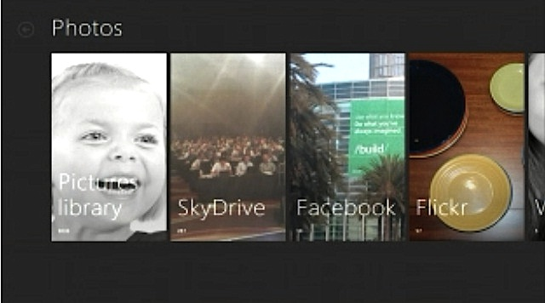
Photo app
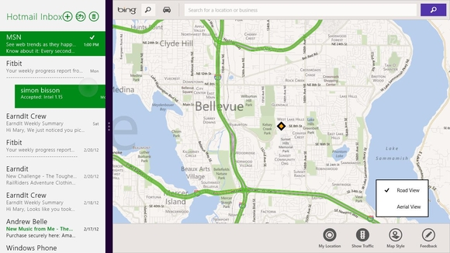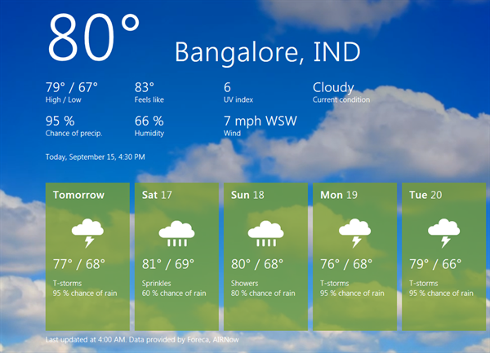
Bing maps weather app

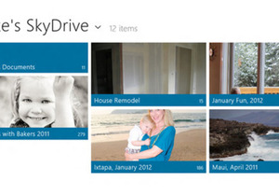
SkyDrive is acutely integrated into the Windows 8 experience. It can sync you address book, photos, whatever you put into your SkyDrive box or even data used by other applications, which they might need for later. All it takes is a simple sign-in and SkyDrive will be lock and loaded. SkyDrive also syncs the same data across various Windows 8 devices. This means you can sync your Windows 8 settings, taskbar, themes or even languages from one machine to another.
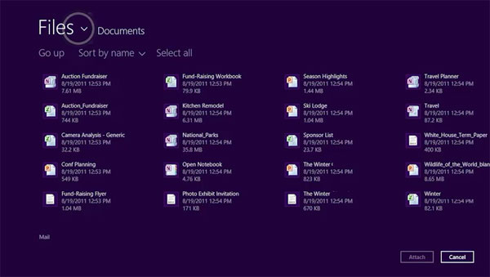
Internet Explorer 10 on Metro has been called ‘a two-faced work-in-progress’ as we now have Internet Explorer as full screen Metro interface app and the conventional desktop workspace sharing a common rendering engine. What IE10 Metro does add are touch features including the side-by-side viewing mode and Windows 8′s built-in sharing features to send out links or snippets of text highlighted on a page. Tablet presentation is better served as IE10 automatically adds space around web page elements like buttons and check boxes to make them easier to tap. 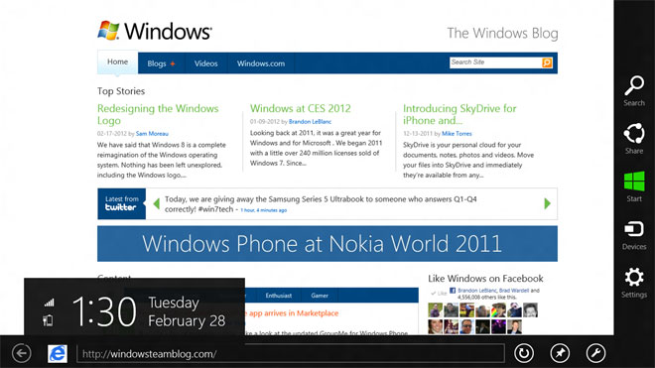
Metro UI Internet Explorer 10
It is simple and for casual browsing, it works but there are minimal support for plugins and no flash player. The conventional IE 10 desktop browser will still function with plugins, providing compatibility for Flash and an all the other extensions, which is why there’s a socking great “Use Desktop View” button for working with Flash and Microsoft’s own ActiveX or Silverlight controls when needed.
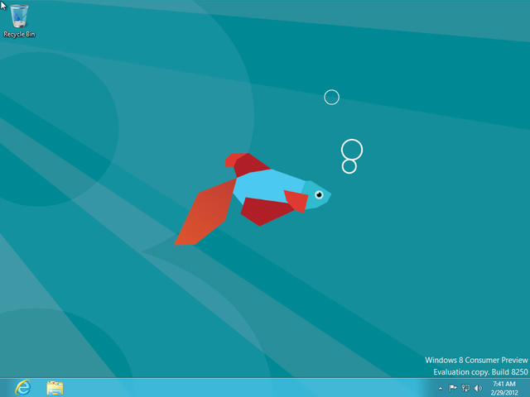
The windows 8 desktop looks similar to Popular and polished windows 7 desktop. The Windows 8 desktop addresses all of our complaints, such as there are irritations like Explorer jumping the view back as you explore deep nested folders, and the intrusive language toolbar but it also takes away the familiar Start menu. Does that make it hard to use, with or without touch? There’s no denying that this is a different way of working; press the Start key on your keyboard and yes, you get the Metro Start screen. This might be a bit annoying for the traditional windows users.
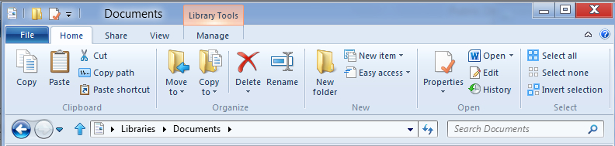
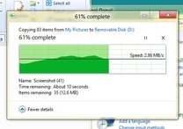
The explorer window now incorporates ribbon view. The ribbon works well for exposing buried features in Explorer like extracting compressed files, selecting every file that isn't currently selected, opening a command prompt and doing things Explorer has enabled you to do before in awkward ways you had to be an expert to remember. Look around the desktop and you'll find all the built-in apps you expect; Paint, WordPad, Notepad, Windows Media Player and Media Center, Control Panel, Sticky Notes and so on. Explorer and Task Manager get most of a makeover. Microsoft has scratched its head and has come with some new extras whilst copying. You can view a detailed report visualized with a fancy graph. You can also pause the copying process and resume it.

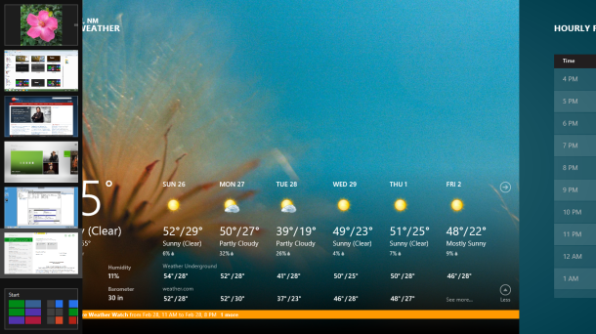
You can also switch between the new Metro UI look and the classic Desktop view in a jiff. Or, you can also have them side-by-side. If there's a Metro app pinned at the side - which you can easily do by dragging the thumbnail that appears when you mouse into the top left corner – Alt + Tab respects that and switches the app in the pane you were working in last. Windows plus the '.' key swaps apps between the different window positions on screen at top speed. There are far more ways of switching between apps than before, so you can pick the ones you prefer and ignore the others. If you want quick access to desktop tools without going back to the Start screen at all, right-click in the very farthest point of the left-hand corner to get a handy menu with just about everything you could want: Search, Run, open Explorer, Task Manager or Control Panel, run tools such as Disk Management, Device Manager, Event Viewer or Power Options. And there's still Windows + R to run any app directly. Frankly, this addresses any complaints about losing the old Start menu; there are neat and efficient ways to get to everything you want in the desktop without ever taking your hands off the desktop or having to see Metro.
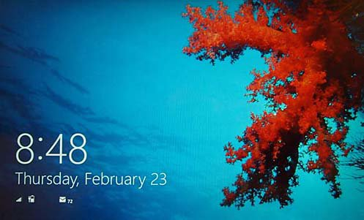
Windows 8 also features a spectacular lock screen. It displays notifications for the number of emails waiting, battery level, and Wi-Fi signal strength. To make it easier to log in to a touch tablet, you can set up a Picture Password. This lets you log it with a set sequence of taps, line, and circles on an image of your choice.
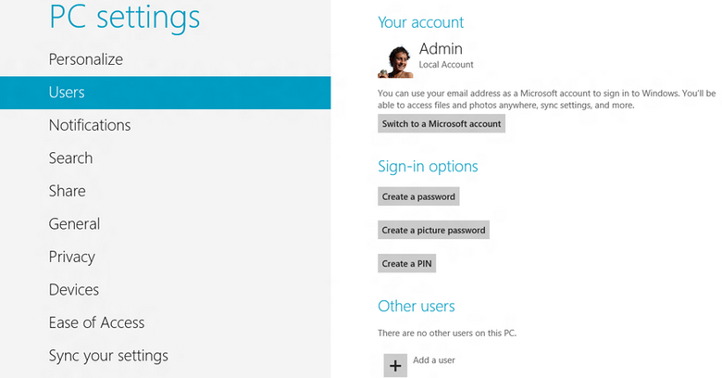
Windows 8 now requires a windows id in-order to create a user. Windows 8 uses this account to take your settings, IE favorites and saved passwords to any other Windows 8 PCs you sign into with the same account, but this is now called a Microsoft account and it will enable you to download apps from the Windows Store. Without a Microsoft account user will not be able to customize the windows. If you use a Windows Live account to log in, you automatically get your contacts, calendar and messages. If you've already linked your Twitter, Facebook, LinkedIn or Flickr accounts to Windows Live, Windows 8 uses that to put your Facebook photos in the Photos app, your Facebook friends in the People app and Facebook chat in Messaging.
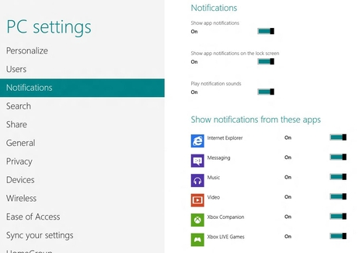
Some apps even have the option to notify the user about new update. You can pick up to seven apps that will run in the background when your screen is off and tell you if you have new messages - one of them can show more detailed information, but so far the calendar is the only choice.

On the whole the interface is far more usable, whether you have a touchscreen or a mouse, and you should quickly master the gestures for switching and closing apps. The overall feel of Microsoft’s new Windows feels slightly refreshed. Things such as the updated Task Manager are great example. It’s more streamlined than before and is much more engaging making you not hate it every time you open it. The Consumer Preview also proves that Windows 8 isn't all about touch. The improvements to the desktop are very welcome, although we'd call them evolution rather than revolution. And if you want to spend most of your time in the desktop you can pin apps to the taskbar and stay there until you want to explore the Start screen. This is the version of Windows 8 that will enable you to decide what you think of Windows 8, and if you approach it with an open mind, you may be surprised by how usable Metro can be. On the other hand, Microsoft clearly has more work to do, both on Windows 8 itself and on the Windows Live apps that showcase Metro, and there are many key features such as sharing and search contacts that will only be useful when there are far more apps to work with them. Windows 8 has to both deliver worthwhile improvements in the way you use your PC today - which it mostly does - and take a major leap forward for tablets and other upcoming PC form factors. That won't be enough, but it's a very promising start.

--> Article by,
Vivek kurmi
Soumyadeep Ghosh

